**Assessing Health Risk Factors System with health drinks recommendation**

Priyankar Dey

Date:03-07-2023

1. ***Abstract:***

*The current generation, despite knowing so much about healthy eating follow extremely unhealthy diets. One of the biggest reasons why the young generation has such unhealthy food habits is because they are busy almost all the time and this serves as an excuse for not having proper meals.*

*Some of the health risks are:*

1. *Type-2*[*diabetes*](https://www.lybrate.com/topic/diabetes)
2. *Weak teeth and*[*tooth decay*](https://www.lybrate.com/topic/tooth-decay)
3. *Cardiovascular diseases*
4. *Inflated blood pressure*
5. *Increase in cholesterol level*
6. *Obesity*
7. [*Stress*](https://www.lybrate.com/topic/stress-disorder)
8. [*Depression*](https://www.lybrate.com/topic/depression)

*Predictive analytics is used here with statistical algorithms and machine learning techniques and using Naive Bayesian algorithm which works on probabilistic approach more specifically Multinomial NB since multiple symptoms are taken to identify the likelihood of future outcomes of health risk based on historical data of client and his\her family.*

*In this report we have devised an optimal way to predict possible risks a person can have so as to get a glance about the health and with a solution to how to prevent the risk.*

1. ***Problem Statement:***

*Providing a methodological approach to analyze the different health factors in depth to get insights about the BMI and determining factors for the increase in health risk along with using the concept of machine learning to train the model accordingly and predict whenever required.*

1. ***Market//Business Need Assessment:***

*Consumers are heeding the proliferation of linking food and beverage consumption with health. Owing to this factor, consumers are increasingly shifting toward maintaining a healthy lifestyle that aids in sustaining fitness while reducing the chances of lifestyle diseases.*

*Our aim is to analyse the different risk along with other risk factors for the clients which will help Individuals to get a glance about their future health risk.*

*Here we are mainly targeting the HEALTH DRINKS MARKET. The health drinks market is one of the fastest-growing markets in the world.*

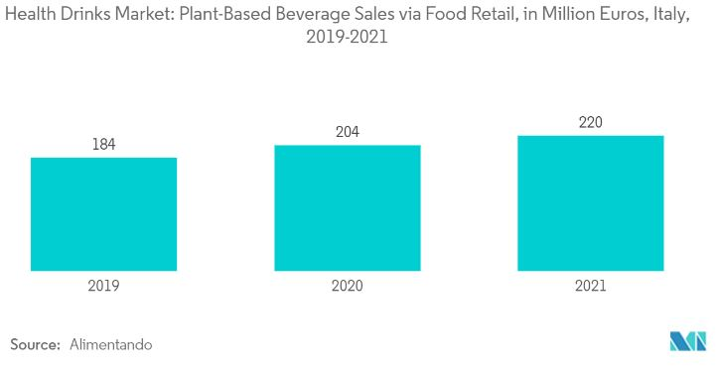

1. ***Target Specifications and Characterization:***

*Classical diagnosis method is a process where the patient has to visit a doctor, undergo various medical test and then come to a conclusion which is very time consuming.*

*The global health drinks market size was valued at USD 478.10 billion in 2019 and is anticipated to expand at a CAGR of 6.06% in terms of value during the forecast period.*

*Consumers approach wellness in a holistic view these days and they prefer drinks that give more health benefits to them. Several consumers want functional and healthy beverages and this trend is taking over drinks. Consumers have become more health-conscious, and they're willing to try healthier alternatives to traditional soft drinks.*

The full report: [https://www.reportlinker.com/p05927294/?utm_source=PRN](https://c212.net/c/link/?t=0&l=en&o=2851559-12&h=2102072662&u=https%3A%2F%2Fwww.reportlinker.com%2Fp05927294%2F%3Futm_source%3DPRN&a=https%3A%2F%2Fwww.reportlinker.com%2Fp05927294%2F%3Futm_source%3DPRN)

1. ***Applicable Regulations***

*Standards set by FSSAI for Health-Drink Industries:*

*The FSSAI has set the following requirements for health drinks:*

* *Customers should be aware of what they are drinking if the manufacturer includes a safety warning on the drink’s label.*
* *The usage restriction should also be written on the label.*
* *Furthermore, the label should state whether the drink is unsafe for pregnant women or children*

*Penal Offenses under FSSAI:*

* *Failure to obtain an FSSAI license carries a six-month sentence as well as a fine of up to Rs. 5 lakhs.*
* *Food that is not fit for human consumption carries a penalty of up to 5 lakhs rupees.*
* *In the event of death, a penalty of not less than Rs 5 lakhs will impose.*
* *In the case of any serious injury penalty of up to 3 lakhs is applicable.*
* *Food quality concerns or if the food sold does not meet the specified quality standard, a penalty of up to Rs 5 lakhs may be imposed.*

1. ***External Search***

* [*https://www.prnewswire.com/news-releases/global-health-drinks-market-consumer-behavior-analysis-by-countries-buying-pattern-analysis-demographics-trends-analysis-survey-findings-and-results-leading-companies-and-their-market-strategies-301090145.html*](https://www.prnewswire.com/news-releases/global-health-drinks-market-consumer-behavior-analysis-by-countries-buying-pattern-analysis-demographics-trends-analysis-survey-findings-and-results-leading-companies-and-their-market-strategies-301090145.html)
* [*https://www.mordorintelligence.com/industry-reports/global-health-drinks-industry*](https://www.mordorintelligence.com/industry-reports/global-health-drinks-industry)
* [*https://www.reportlinker.com/p05927294/?utm_source=PRN*](https://c212.net/c/link/?t=0&l=en&o=2851559-12&h=2102072662&u=https%3A%2F%2Fwww.reportlinker.com%2Fp05927294%2F%3Futm_source%3DPRN&a=https%3A%2F%2Fwww.reportlinker.com%2Fp05927294%2F%3Futm_source%3DPRN)

1. ***Business Model :***

*The business model for the Assessing Health Risk Factors System can be designed to generate revenue and create value for both the retailers and the end customers.*

*The model will use Direct Selling*

*What Is Direct Selling?*

*Direct selling is our business model. Simply put, it is a person-to-person sale. The model avoids intermediaries in the supply chain and sells products directly to consumers. Millions of people around the world choose to become involved in direct selling because they enjoy a company’s products.*

1. *Customers would be provided with an app where he\she would be have to provide some of his health details and family health details and our system will generate his\her health risk factors and also will be recommended by some of the health-drinks (Ayurveda) for the risk management and also with a business mentor.*
2. *Customers should be charged with some the product price and also they are eligible to earn a commission and bonus if they can make join some more customers to the app who buy at least one product.*
3. *Since distributors working as business mentors personally know the person interested in trying this business opportunity, they are prepared to offer personalized guidance based on the entrepreneur’s particular needs, skills, strengths, and goals.*
4. *These mentorship relationships can work in both directions: distributors who mentor continue to sharpen their own business skills while building their teams, and the new entrepreneur benefits from their support as they begin their own journey to business ownership.*

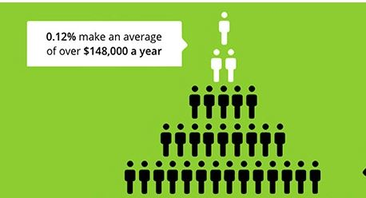

1. ***Final Product Prototype***

*The Assessing Health Risk Factors System with health drinks recommendation app's final product prototype includes the following*

*Components:*

* *User Interface (UI):* *A visually appealing and user-friendly interface that allows users to input their historic details of diseases and view their health risks and the product needed to manage their risks.*
* *Data Pre-processing: Cleaning, normalizing, and transforming the data to ensure it quality and compatibility with the machine learning algorithms.*
* *Machine Learning Model: Utilizing machine learning algorithms to analyse the data and generate accurate health risks.*
* *How does it work? : It will show the recommended health drinks (Ayurveda) products and also with a unique code to share with other members to join.* *If you’re a new recruit, then you want to focus on finding new customers to buy products and new recruits to join your organization.* *Each new distributor opens up a new sales channel.* *It’s similar to an insurance broker hiring new agents. There’s a tremendous amount of opportunity when you have a team of distributors to help pass the promotional materials out to make new sales without you.*
* *Most distributors can connect them though their unique ID and sell products to friends and family to supplement their income by getting commission , while others use their experience to take charge, building their own small business through a network of direct sellers*

*Schematic Diagram:*

Members can also make money by recruiting other members into the company.

Recommending member with Ayurveda health drinks

Preprocessing of data

Machine Learning Model

1. ***Conclusion*** *:*

*In the market there are different apps available that serves or distributes health products but customers do not know what product they actually require and buys them which are also costly and therefore many mediocre cannot afford those. Each person’s nutrition needs are different and require a unique, personalized nutrition plan that is not available at brick-and-mortar and online retail.*

*Our model will be able to predict the health risk which will help people to buy the correct product and they will easily can afford those product by connecting and selling them the products which their unique ID generated by our App.*

END